CENWP-OD 08 May 2020

MEMORANDUM FOR THE RECORD

SUBJECT: 20WVP07 MFR Trout Stocking Fish Loss

On 30 April 2020, the contractor, Desert Spring Trout Farm (DSTF) of Summer Lake, Oregon, arrived to the planned release site of Junction City Pond, in Lane County, Oregon. The truck had suffered equipment malfunction during the shipment. As a result, about 200 rainbow trout (O. mykiss) were negatively impacted. Many of these fish were deceased upon arrival, with others severely debilitated, or moribund.

About 1000 on 30 April, DSTF personnel released the truck load of fish and documented that some trout were delivered in a morbid state. 93 legal sized trout were collected by dip net. Another 100 were out of reach of the dip net and left in the pond. The driver of the DSTF delivery truck took photos of the release site and documented the dead fish (Figure 1).

By 1500 on 30 April DSTF contacted the USACE contract officer representative (COR) (Bob Wertheimer) to report the incident. The COR, directed that an in kind replacement delivery (i.e., replacing the same # and size classes of deceased trout) be mobilized from DSTF at Summer Lake to Junction City Pond that afternoon due to the importance of the fishery.

By 1900 on 30 April another delivery of fish was made and the contract requirements for fish size and quantity were met.

On 1 May 2020, ODFW contacted the COR via email (included below) with the following concerns: “Junction City Police received a 911 call stating that that people were netting trout out of Junction City Pond from the right side of the dock and keeping these fish.” The COR worked with DSTF and ODFW to ensure accurate reporting and responses to the incident.

On 5 May 2020, a Draft Incident Report was delivered to the COR and communication ensued to determine the proper avenues for after action clean up and reporting.

On 6 May 2020 a final Incident report was delivered to the COR. Details from that report are below.

At about 0830 on 30 April 2020 Desert Springs truck (unit) #04 left the trout farm loaded with trout for Junction City Pond. One compartment of the truck (#4) contained 1,717 fish at 2.29 fish per pound and 107 fish at 0.43 fish per pound in tank (#3). See Table 1 for specific data.
Per operational procedure, the level of liquid oxygen in the on-board cylinder was checked and the gauge indicated a bit over 3/8 full, an amount well within scope to complete the delivery. The secondary reserve high pressure oxygen cylinder (used if the liquid fails) was also checked and found to be within scope. The cylinders were filled the night before and allowed to chill prior to transport the next day. The driver stopped to check support systems about 45 minutes into the trip and the oxygen flow meters were still at the proper level. Approximately 30 minutes later he stopped again and noticed the oxygen flow meters had dropped significantly. Investigation revealed that the liquid oxygen cylinder was near empty, although it was still registering above 1/4 full on the gauge. The backup, high pressure oxygen cylinder, was operated when the faulty gauge on the liquid cylinders was found and salvaged what might have been a complete loss of fish.
Unfortunately, the driver released the fish despite knowing that there may have been mortalities. His intent was to deliver as many fish as possible to this important fishery. The fish tanks lids were not opened prior to release for fear of stressing fish and causing more mortality. The fish were released and the cumulative mortality was evidenced upon fish entering the pond.
The manager at DSTF has suspended the use of the truck until the O2 cylinder gauges can be replaced. DSTF accepts that although the gauge was faulty, a more thorough inspection of the equipment might have found this issue.
DSTF ensured fish were replaced. They also continued to collect morbid fish immediately after the release, during the second replacement release, and a week later on 6 May 2020.

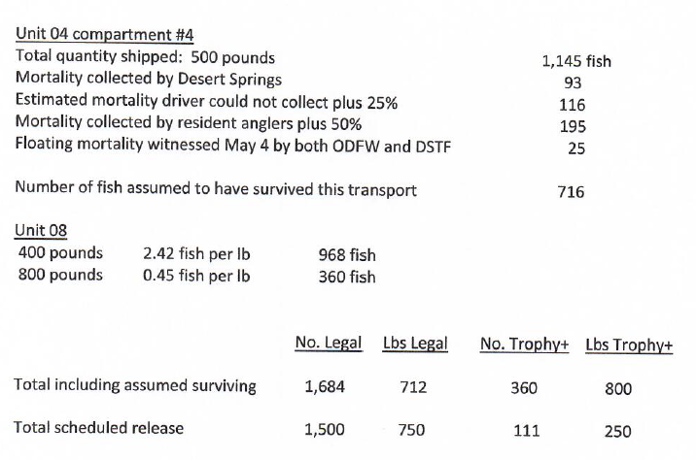
Table 1. Data Rainbow Trout (O. mykiss) delivered moribund and alive to Junction City Pond by USACE contractor on 30 April 2020.

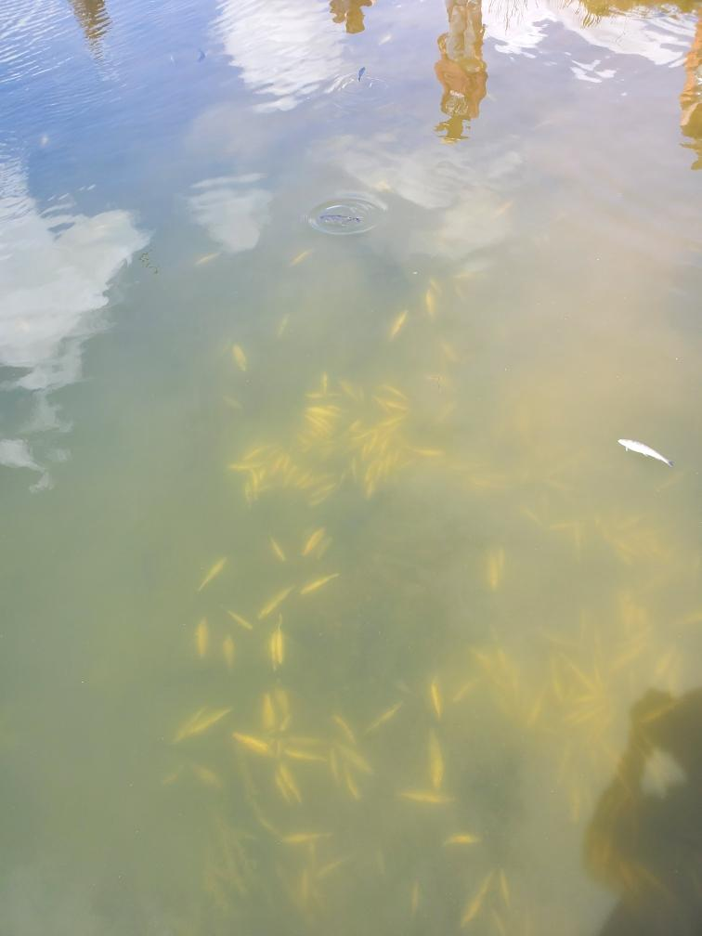
Figure 1. Image of approximately 93 Rainbow Trout (O. mykiss) delivered moribund to Junction City Pond by USACE contractor on 30 April 2020.

A. Species – Rainbow trout (triploid).
B. Origin – Desert Springs Trout Farm
C. Size – Legal/Trophy+
D. Future and Preventative Measures – Faulty gauges have been ordered and will be replaced. All critical backup operations will continue to be checked prior to departure.

Please email or call with questions or concerns.
Thank you,

Chris Walker
NWP Operations Division Fishery Section
Christopher.E.Walker@usace.army.mil

---
Communications.
-----Original Message-----
From: Wertheimer, Robert H CIV USARMY CENWP (USA)
Sent: Wednesday, May 6, 2020 5:18 AM
To: Ethan Negus <ethan.negus@desertspringstroutfarm.com>
Cc: Tidwell, Kyle S CIV (USA) <Kyle.S.Tidwell@usace.army.mil>; Walker, Christopher E CIV USARMY USACE (USA) <Christopher.E.Walker@usace.army.mil>; Sachs, Steven A CIV USARMY CHRA-WEST (US) <Steven.A.Sachs@usace.army.mil>; Mackey, Tammy M CIV USARMY CENWP (USA) <Tammy.M.Mackey@usace.army.mil>
Subject: RE: [Non-DoD Source] RE: Trout delivery to Junction City Pond

Thank you Ethan, Please, collect any remaining floaters/morts you can.

I appreciate the update on methodologies. This is not rambling, but an important update on protocols to address DSTF methods and a stakeholder concern.

These concerns are something we take seriously, and I will relay the update to this stakeholder.

v/r
Robert H. Wertheimer
Portland District - Supervisor, Fish Field Unit (FFU).
U.S. Army Corps of Engineers Cascade Locks, OR. 97014
w: 541 374-3651
c: 541 324-1110
FFU Main: 541 374-8801

-----Original Message-----
From: Ethan Negus [mailto:ethan.negus@desertspringstroutfarm.com]
Sent: Tuesday, May 5, 2020 7:10 PM
To: Wertheimer, Robert H CIV USARMY CENWP (USA) <Robert.H.Wertheimer@usace.army.mil>
Subject: Re: [Non-DoD Source] RE: Trout delivery to Junction City Pond

Thank you Bob,
If it’s okay with you I would still like to send a mort net and container with the driver tomorrow and have him collect as many of those floaters as he can. I suspect they are from the incident that eventually bubbled up - just undesirable optics, bad memories etc.
If relevant, we strive to be within 7 degrees F of the receiving water body temp when the truck arrives, a standard set by ODFW. In the past we have measured temperature increases of up to one degree F per hour on a hot day (85-90+). Admittedly targeting this temp variance is done by gut and assumption of the approx. temperature of receiving water at a given time of season, and to a lesser extent recent weather patterns. Some base knowledge of historical water temps has been acquired through past deliveries when contracting with ODFW to many of the same locations we are currently stocking for U.S. Army Corps of Engineers, as this is one of the parameters we were required to measure prior to releasing the trout. As a general rule we are a lot more careful to not be in excess of 7 degrees below than above the receiving water temp, something that the continuous 60 degree F water at the facility makes easier to achieve. Ice that is produced on site is used to transport live trout during hotter periods more as a means of controlling the transport water temperature than of creating an opportunity to increase hauling density and hauling densities are lowered during summer months to avoid any need for excess chilling of transport water.
Sorry I didn’t mean to ramble on but I felt I needed to explain how we approach this concern.

Ethan Negus
Desert Springs Trout Farm
w:(541) 943-3192
c: (541) 815-4066

On May 5, 2020, at 4:16 PM, Wertheimer, Robert H CIV USARMY CENWP (USA) <Robert.H.Wertheimer@usace.army.mil <mailto:Robert.H.Wertheimer@usace.army.mil> > wrote:

Hey Ethan, ODFW’s final sentence has relevance for tomorrow. No final on site action needed.
Please, deliver the revised incident report and we will discuss after.

Thanks Ethan, Bob

Sent with BlackBerry Work
(Blockedwww.blackberry.com <Blockedhttp://www.blackberry.com/> )

From: Elise X Kelley <Elise.X.Kelley@state.or.us <mailto:Elise.X.Kelley@state.or.us> >
Date: Tuesday, May 05, 2020, 3:07 PM
To: Wertheimer, Robert H CIV USARMY CENWP (USA) <Robert.H.Wertheimer@usace.army.mil <mailto:Robert.H.Wertheimer@usace.army.mil> >
Cc: Alex Farrand <Alex.Farrand@state.or.us <mailto:Alex.Farrand@state.or.us> >, Brian Wolfer <Brian.H.Wolfer@state.or.us <mailto:Brian.H.Wolfer@state.or.us> >, Dillon M Alegre <Dillon.M.Alegre@state.or.us <mailto:Dillon.M.Alegre@state.or.us> >, Jeffrey Ziller <Jeffrey.S.Ziller@state.or.us <mailto:Jeffrey.S.Ziller@state.or.us> >, Karen Hans <Karen.M.Hans@state.or.us <mailto:Karen.M.Hans@state.or.us> >, kelly.e.reis@state.or.us <mailto:kelly.e.reis@state.or.us> <kelly.e.reis@state.or.us <mailto:kelly.e.reis@state.or.us> >, Ryan Couture (ryan.b.couture@state.or.us <mailto:ryan.b.couture@state.or.us> ) <ryan.b.couture@state.or.us <mailto:ryan.b.couture@state.or.us> >, Walker, Christopher E CIV USARMY USACE (USA) <Christopher.E.Walker@usace.army.mil <mailto:Christopher.E.Walker@usace.army.mil> >, Mackey, Tammy M CIV USARMY CENWP (USA) <Tammy.M.Mackey@usace.army.mil <mailto:Tammy.M.Mackey@usace.army.mil> >, Tidwell, Kyle S CIV (USA) <Kyle.S.Tidwell@usace.army.mil <mailto:Kyle.S.Tidwell@usace.army.mil> >
Subject: [Non-DoD Source] RE: Trout delivery to Junction City Pond

Hi Bob,
Thank you for sending the report below. It helps to know DTSF's perspective on what happened and the actions that DTSF took to try to prevent the problem. We appreciate the driver trying to net out some of the dead trout. We also appreciate DTSF and USACE's rapid response in replacing the trout. From ODFW's perspective there's just a few items left to clarify:

1. When Ethan uses the term "legal size" below, he is referring to 2 fpp size fish (at ODFW the term "legal size" refers to 3 fpp fish, so generally smaller fish than what USACE/DSTF is delivering).
2. I know you are still reviewing the report and determining your response, but can we assume that in the future if an incident like this occurs DTSF will notify USACE as soon as possible and that USACE also contact ODFW as soon as possible? I know you have other responsibilities and may not be able to reach out as quickly as you would prefer to, but early notification can allow ODFW to respond more rapidly to the situation, and perhaps avoid illegal activities like the netting of trout that took place in this case.
3. There wasn't mention in DSTF's report of whether the driver interacted with anglers, and if so what was said. Could USACE verify whether the driver did suggest that people net fish up, or if he had other conversations with the anglers present? We're not interested in pointing fingers, just in fully understanding the facts and reconciling the different reports of what occurred. We're assuming at this point that folks at DTSF know that it is illegal for anglers to use nets to harvest trout (if they were not aware of it before).
4. Though this incident turned out not to be temperature related, we would still be interested to know what the allowable temperature differential is between a lib truck and a waterbody. I think generally this is unlikely to be an issue, but it's helpful to know the parameters and the process for equalizing temperatures between a delivery truck and waterbody if needed. If there isn't a protocol because this isn't expected to be an issue, knowing that would be helpful too.

No fish were seen at the bottom of Junction City Pond yesterday. About 15-25 floaters were spotted around the pond, but there isn't anything connecting those to the delivery. From ODFW's perspective no further on-site action is needed at this time.

Thanks for working with us on this,
Elise

-----Original Message-----
From: Wertheimer, Robert H CIV USARMY CENWP (USA) <Robert.H.Wertheimer@usace.army.mil <mailto:Robert.H.Wertheimer@usace.army.mil> >
Sent: Monday, May 4, 2020 9:11 AM
To: Elise X Kelley <Elise.X.Kelley@state.or.us <mailto:Elise.X.Kelley@state.or.us> >
Cc: Alex Farrand <Alex.Farrand@state.or.us <mailto:Alex.Farrand@state.or.us> >; Brian Wolfer <Brian.H.Wolfer@state.or.us <mailto:Brian.H.Wolfer@state.or.us> >; Dillon M Alegre <Dillon.M.Alegre@state.or.us <mailto:Dillon.M.Alegre@state.or.us> >; Jeffrey Ziller <Jeffrey.S.Ziller@state.or.us <mailto:Jeffrey.S.Ziller@state.or.us> >; Karen Hans <Karen.M.Hans@state.or.us <mailto:Karen.M.Hans@state.or.us> >; kelly.e.reis@state.or.us <mailto:kelly.e.reis@state.or.us> ; Ryan Couture (ryan.b.couture@state.or.us <mailto:ryan.b.couture@state.or.us> ) <ryan.b.couture@state.or.us <mailto:ryan.b.couture@state.or.us> >; Walker, Christopher E CIV USARMY USACE (USA) <Christopher.E.Walker@usace.army.mil <mailto:Christopher.E.Walker@usace.army.mil> >; Mackey, Tammy M CIV USARMY CENWP (USA) <Tammy.M.Mackey@usace.army.mil <mailto:Tammy.M.Mackey@usace.army.mil> >; Tidwell, Kyle S CIV (USA) <Kyle.S.Tidwell@usace.army.mil <mailto:Kyle.S.Tidwell@usace.army.mil> >
Subject: RE: Trout delivery to Junction City Pond

Hey Elise/ALCON;
Please, find below the incident report I received from DSTF.
I am still reviewing the incident, and would appreciate any input you have.

Thanks,
Robert H. Wertheimer
Portland District - Supervisor, Fish Field Unit (FFU).
U.S. Army Corps of Engineers Cascade Locks, OR. 97014
w: 541 374-3651
c: 541 324-1110
FFU Main: 541 374-8801

-----Original Message-----
From: Ethan Negus [mailto:ethan.negus@desertspringstroutfarm.com]
Sent: Friday, May 1, 2020 10:54 AM
To: Wertheimer, Robert H CIV USARMY CENWP (USA) <Robert.H.Wertheimer@usace.army.mil <mailto:Robert.H.Wertheimer@usace.army.mil> >
Subject: [Non-DoD Source] April 30 Junction City Pond

Hello Bob,
This message is a follow-up to our brief discussion yesterday regarding some fish losses that we experienced within our partial release at Junction City Pond on April 30. Desert Springs truck (unit) #04 left the farm at approximately 8:30 am, loaded with 1,000 pounds of trout for Junction City Pond and 600 pounds for Foster Reservoir. Each delivery location was afforded two compartments to evenly split its designated pounds. For Junction City, one compartment (#4) contained 500 pounds of legal size and the other (#3) contained 250 pounds of legal and 250 pounds of trophy+. As is part of our standard practice for pre-trip operations the level of liquid oxygen in the on-board cylinder was checked and the gauge indicated a bit over 3/8 full, well within the necessary amount to complete the delivery even with unanticipated delays. All of our trucks carry a high pressure oxygen cylinder as backup in case of a rare fault with the liquid cylinder, or some other unforeseen circumstance.
The driver stopped to check support systems about 45 minutes into the trip and the oxygen flow meters were still at the proper level. Approximately 30 minutes later he stopped again and at that time noticed the oxygen flow meters had dropped significantly. After a short investigation it became obvious that the liquid oxygen tank was near empty, although it was still registering above 1/4 full on the gauge. He switched the regulator over to the high pressure cylinder and telephoned me at the farm to make sure that I thought this would be enough to complete the delivery. The 1800 lbs of oxygen within the cylinder was more than enough to complete the delivery route so I told him to open the tank lids and check the condition of the fish, and if they looked okay, to proceed. He said there were a few fish in compartments 3 and 4 that were rolling, but looked to be coming around so I told him to continue.
He stopped again a short distance from the first drop location, Junction City Pond and cracked the tank lids open to try to be sure there weren't a bunch of "floaters" on board. We are aware of how unfavorably anglers react to seeing any dead fish being released and none of our drivers wants to be at the forefront of a situation like that. The truck arrived at approximately 1:30 pm and compartment 4 was released with the thought in mind that there might be a half dozen mortality. Unfortunately it was considerably more than that. Unable to reach me by telephone, the driver made the decision to not release the other half of the allotment for Junction City Pond, fearing a repeat of the first compartment. He fully opened the lids on the remaining 3 compartments so as to get a closer look at the condition of the fish. Compartments 1 and 2 with just 300 pounds each for Foster Reservoir looked good, but compartment 3 had some visible mortality.
Driver was able to contact me shortly before 2:00 pm while on his way to Foster and informed me of the incident. Knowing how much activity this pond receives we felt extremely compelled to try to correct the situation quickly and to the best of our ability. An available transport truck was prepared, a driver secured and replacement fish loaded within about an hour. The driver was sent with a long handle mortality net and a container, and was instructed to collect as many of the dead fish as possible and return them to the farm. The replacement fish arrived at Junction City Pond at approximately 7:00 pm and no mortality were noted.
Truck #4 delivered successfully at Foster Reservoir with only 3 mortality and returned to the farm with the balance of the initial Junction City Pond allotment. Upon returning, compartment #3 was dumped into an empty fish raceway. At nearly dark the mortality was only estimated at forty fish. This morning a total of 61 mortality were collected, all within the legal size range. The dead fish that were collected from Junction City Pond were also counted at 93, all legal size. The driver who delivered the replacement fish and collected these took photos of fish at the pond bottom prior to beginning retrieval, and he estimated there were about an equal number that he could not reach with his net.
Until we are able to either obtain a replacement gauge, or have the liquid oxygen tank repaired or replaced, this tank will be clearly marked and all employees informed of this hazard misreading.

Ethan Negus
Desert Springs Trout Farm
w:(541) 943-3192
c: (541) 815-4066

-----Original Message-----
From: Wertheimer, Robert H CIV USARMY CENWP (USA)
Sent: Friday, May 1, 2020 9:24 AM
To: Elise X Kelley <Elise.X.Kelley@state.or.us <mailto:Elise.X.Kelley@state.or.us> >
Cc: Alex Farrand <Alex.Farrand@state.or.us <mailto:Alex.Farrand@state.or.us> >; Brian Wolfer <Brian.H.Wolfer@state.or.us <mailto:Brian.H.Wolfer@state.or.us> >; Dillon M Alegre <Dillon.M.Alegre@state.or.us <mailto:Dillon.M.Alegre@state.or.us> >; Jeffrey Ziller <Jeffrey.S.Ziller@state.or.us <mailto:Jeffrey.S.Ziller@state.or.us> >; Karen Hans <Karen.M.Hans@state.or.us <mailto:Karen.M.Hans@state.or.us> >; kelly.e.reis@state.or.us <mailto:kelly.e.reis@state.or.us> ; Ryan Couture (ryan.b.couture@state.or.us <mailto:ryan.b.couture@state.or.us> ) <ryan.b.couture@state.or.us <mailto:ryan.b.couture@state.or.us> >; Walker, Christopher E CIV USARMY USACE (USA) <Christopher.E.Walker@usace.army.mil <mailto:Christopher.E.Walker@usace.army.mil> >; Mackey, Tammy M CIV USARMY CENWP (USA) <Tammy.M.Mackey@usace.army.mil <mailto:Tammy.M.Mackey@usace.army.mil> >; Ethan Negus <ethan.negus@desertspringstroutfarm.com <mailto:ethan.negus@desertspringstroutfarm.com> >; Tidwell, Kyle S CIV (USA) <Kyle.S.Tidwell@usace.army.mil <mailto:Kyle.S.Tidwell@usace.army.mil> >
Subject: RE: Trout delivery to Junction City Pond

Thanks Elise,
Ethan from Desert Springs Trout Farm (DSTF) called me yesterday afternoon and informed me that due to a DO sensor issue on the truck, dead or moribund fish were released.

I directed DSTF to:
1) Provide a complete incident report that I have yet to receive,
2) Estimate the size of the fish loss, and to return to Junction City Pond, and replace with live fish due to the importance of the fishery.

I assume DSTF sent a truck to replace the loss in kind (e.g., same length and weight as the loss).

I just wanted to let you know we are working the issue and we will follow-up with the group once I have a report.

Thanks again for letting me know,
Robert H. Wertheimer
Portland District - Supervisor, Fish Field Unit (FFU).
U.S. Army Corps of Engineers Cascade Locks, OR. 97014
w: 541 374-3651
c: 541 324-1110
FFU Main: 541 374-8801

-----Original Message-----
From: Elise X Kelley [mailto:Elise.X.Kelley@state.or.us]
Sent: Friday, May 1, 2020 9:06 AM
To: Wertheimer, Robert H CIV USARMY CENWP (USA) <Robert.H.Wertheimer@usace.army.mil <mailto:Robert.H.Wertheimer@usace.army.mil> >
Cc: Alex Farrand <Alex.Farrand@state.or.us <mailto:Alex.Farrand@state.or.us> >; Brian Wolfer <Brian.H.Wolfer@state.or.us <mailto:Brian.H.Wolfer@state.or.us> >; Dillon M Alegre <Dillon.M.Alegre@state.or.us <mailto:Dillon.M.Alegre@state.or.us> >; Jeffrey Ziller <Jeffrey.S.Ziller@state.or.us <mailto:Jeffrey.S.Ziller@state.or.us> >; Karen Hans <Karen.M.Hans@state.or.us <mailto:Karen.M.Hans@state.or.us> >; kelly.e.reis@state.or.us <mailto:kelly.e.reis@state.or.us> ; Ryan Couture (ryan.b.couture@state.or.us <mailto:ryan.b.couture@state.or.us> ) <ryan.b.couture@state.or.us <mailto:ryan.b.couture@state.or.us> >
Subject: [Non-DoD Source] Trout delivery to Junction City Pond

Hi Bob,

We had an issue at Junction City Pond yesterday that involved Oregon State Police, and I wanted to rely the incident to you since Desert Spring was mentioned in the recounting.

Junction City Police received a 911 call stating that that people were netting trout out of Junction City Pond from the right side of the dock and keeping these fish. Oregon State Police performed a traffic stop on the "netters" after they had left the Pond and were told that when the Desert Springs driver dropped off the trout many of the fish lay at the bottom of the Pond, appearing dead. They said that the driver stated that the fish were stunned likely due to water temperature differences between the truck and Junction City Pond, and that people could just scoop them up. The people that were stopped by OSP had close to 50 trout on board and stated that they weren't there when the incident occurred, but they heard about it from other folks who were there when it did and who also netted fish off the bottom of the Pond. I am sure that there is another side to the story, however there are a few issues which ODFW would appreciate having addressed:

1. Unquestionably a minimum of 50 trout, and seemingly a significantly greater number than that, were apparently released in poor condition into Junction City Pond by Desert Springs. We understand that truck issues can occur, however this type of situation seldom occurs with trout, and if something like this does happen to an ODFW driver, they retrieve as many of the dead/non-recoverable fish as possible, call the District Fish Biologist to let them know, and work with fish health folks to fill out a report and perform an investigation so that the situation doesn't reoccur. We would appreciate knowing what USACE's process is in a situation like this, and whether similar steps to the above will be implemented. We are, of course, interested in the information gathered including reports or evaluations, and Desert Spring's perspective on the incident.

2. It is against ODFW regulations to net gamefish. An angler may not realize that a Desert Springs driver does not have authority in relation to ODFW Regulations (if indeed the driver did suggest netting fish from the bottom of the pond). Having someone apparently in authority countermanding ODFW regulations can lead to confusion and illegal activities.

3. Please let us know the allowed temperature differential between Desert Springs trucks delivering trout and the waterbody the fish are being delivered to, and how Desert Springs acclimates trout to the temperature of the waterbody if the differential exceeds the allowed difference.

Thanks, I'll look forward to hearing from you, and please let me know if you have questions,

Elise

Elise Kelley, Ph.D.
District Fish Biologist, Mid-Willamette District
Oregon Department of Fish and Wildlife
7118 NE Vandenberg Ave.
Adair Village, OR 97330
Office: 541-757-5249

